Sprint 3 – Agility Design Document

December 7, 2020

Table of Contents
1. Executive Summary 3
1.1 Project Overview 3
1.2 Purpose and Scope of this Specification 3
2. Product/Service Description 3
2.1 Product Context 3
2.2 User Characteristics 3
2.3 Assumptions 3
2.4 Constraints 3
2.5 Dependencies 4
3. Requirements 4
3.1 Functional Requirements 5
3.2 Security 5
3.2.1 Protection 5
3.2.2 Authorization and Authentication 6
3.3 Portability 6
4. Requirements Confirmation/Stakeholder sign-off 6
5. System Design 6
5.1 Algorithm 6
5.2 System Flow 6
5.3 Software 6
5.4 Hardware 6
5.5 Test Plan 7
5.6 Task List/Gantt Chart 7
5.7 Staffing Plan 7

Executive Summary

Project Overview
The Sphero robot should follow the Robotics Triathlon course designated for sprint three located in HH208. The robot will encounter 3 objects that need to be avoided by the robot. It will go over the ramp. Lastly, the robot will make an attempt to knock over as many pins as possible.

Purpose and Scope of this Specification

In scope
- Audience – New Programmers
- Purpose – The software is designed to run over certain smooth surfaces.

Out of Scope
- The robot will not run on sand.
- The robot cannot recover its path if derailed from the course.
- The robot will not be successful in avoiding obstacles.

Product/Service Description

Product Context
The robot endurance project is designed to go around the room and follow the zigzag course located in HH208. This product is designed to entertain children.

User Characteristics

Faculty/Staff
- Experience: Established background experience
- Technical expertise: Established background working with computers and software programs.
- Other: Knowledgeable with different computer programming languages.
College Students
- Experience: Minimal experience - none.
- Technical experience: Has previously taken a computer science course
- Other: Does not have a fundamental understanding of any computer programming language.

Assumptions
- Sphero SPRK robot is required
- Basic understanding of programming in order to use application

Constraints
- Forced to work virtually due to Covid-19
- Difficult schedules to line up meeting arrangements

2.5 Dependencies
- A group member must be on campus to pick up a robot
- Room HH208 is necessary to use in order to test the program
- Sphero Edu application is needed to create code for robot
- Wi-Fi connection for group meetings and project creation

Requirements

Functional Requirements

Req# | Requirement | Comments | Priority | Date Rvwd | SME Reviewed / Approved
ENDUR_01 | Start robot in the square |  | 1st | 12/1 | 12/1
ENDUR_02 | Start obstacle course | Few tries needed to correctly start the course | 2nd | 12/1 | 12/1
ENDUR_03 | Avoid 1st obstacle | Robot hit the object, but eventually we were able to program it to avoid it | 3rd | 12/1 | 12/1
ENDUR_04 | Avoid 2nd Obstacle | Successful avoidance | 4th | 12/1 | 12/1
ENDUR_05 | Avoid Final Obstacle | Successful avoidance | 5th | 12/1 | 12/1
ENDUR_06 | Head towards ramp and over | Fell off ramp multiple times, eventually was able to be programmed to successfully go over | 6th | 12/1 | 12/1
ENDUR_07 | Speed up and Knock Down pins | Had to adjust speed to knock down more pins | 7th | 12/1 | 12/1
ENDUR_08 | Finish |  | 8th | 12/1 | 12/1

Security

Protection
The factor that will protect the system from malicious or accidental access, modification, disclosure, destruction, or misuse encryption is by backing up our program into the cloud.

Authorization and Authentication

An account is created for Sphero, so a password is required in order to view the code. A members only GitHub repository is created to secure access to the program.

Portability
- The code can be accessed through any operating system that has Wi-Fi connection and the robot.
- Block code is a beginner's programming language which makes it easily understandable to anyone.

Requirements Confirmation/Stakeholder sign-off
Include documentation of the approval or confirmation of the requirements here. For example:
Meeting Date | Attendees (name and role) | Comments
12/01/20 | Alicia Sanchez, Carlos Navarro, Michael Mendoza | Confirmed all

System Design

Algorithm
- Start on square
- Run obstacle course
- Avoid 1st object
- Topple
- Avoid 2nd object
- Topple
- Avoid 3rd object
- Topple
- Go up and over the ramp
- Speed up
- Knock down pins

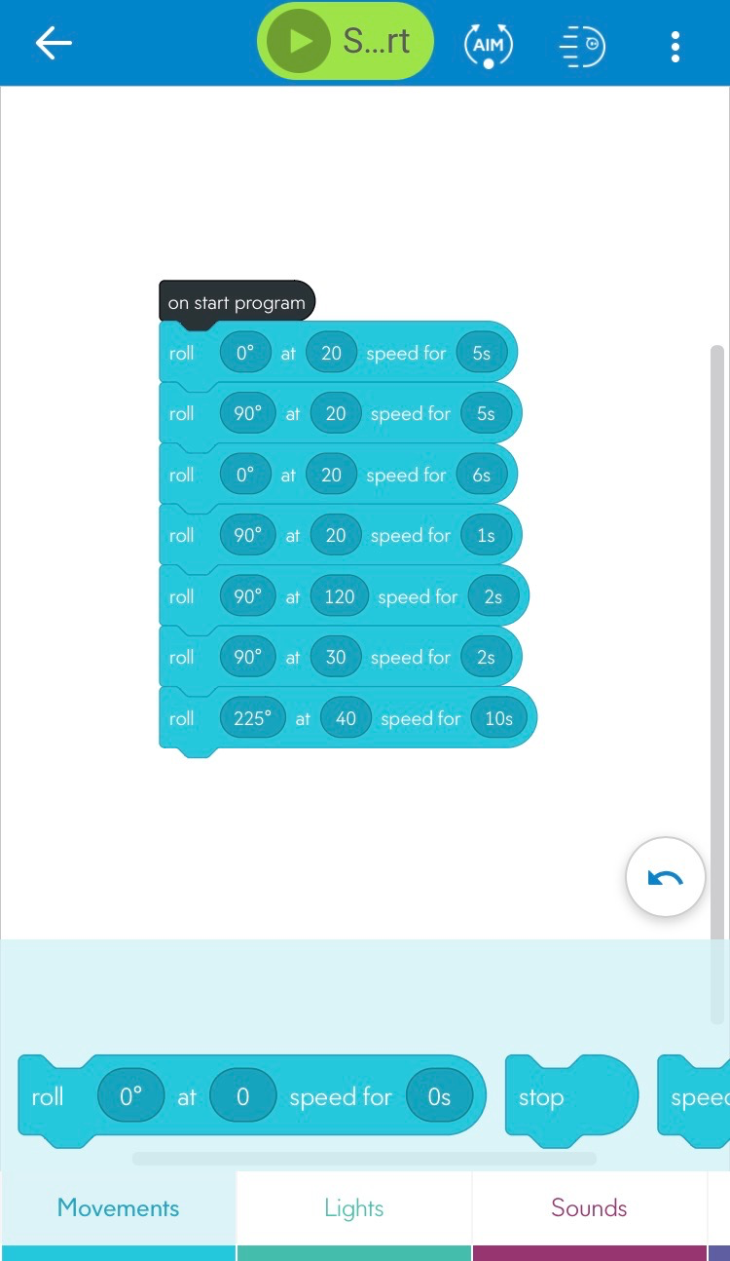

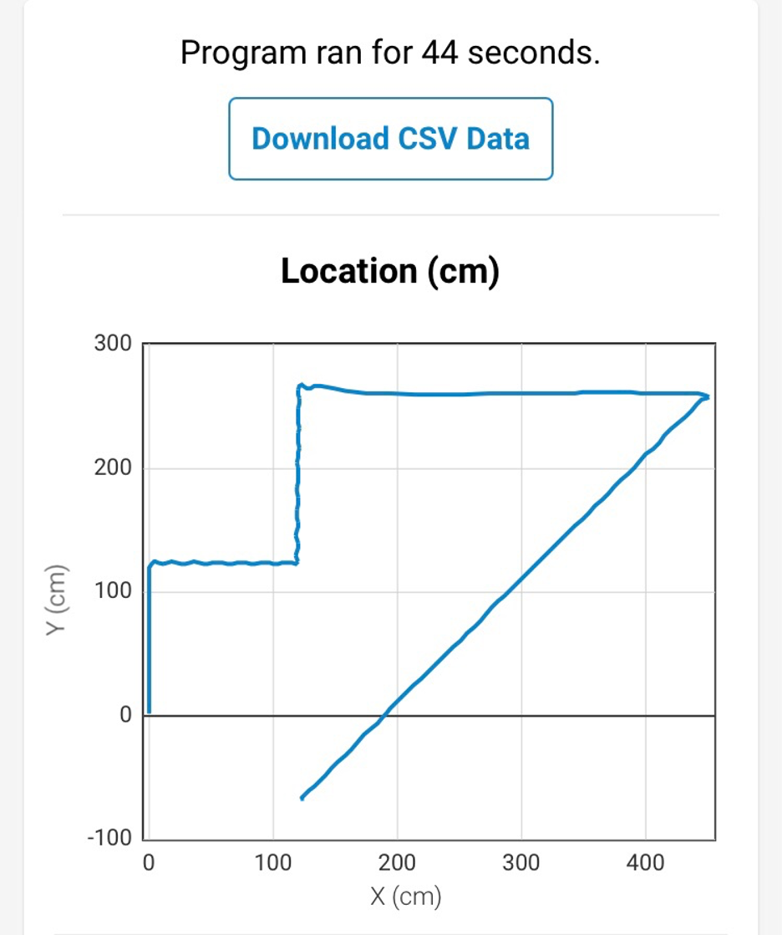

System Flow
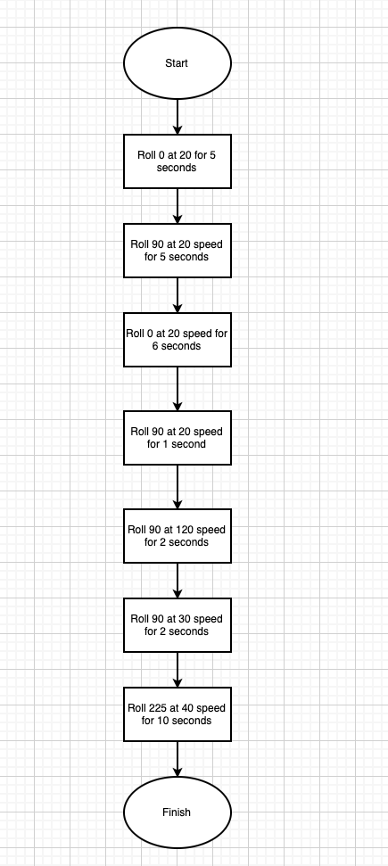

Software
Sphero robots can be programmed with easy drag-and-drop blocks or text-based code. Intermediate coders can utilize the familiar block-based drag-and-drop interface. Pre-programmed blocks allow for a wide variety of actions and variables.

Hardware
The only hardware that is absolutely necessary is the robot itself and a device that supports the Sphero Edu app. The testing took place in room HH208, but with creativity the same ‘obstacle’ course can be recreated anywhere.

Test Plan

Reason for Test Case | Test Date | Expected Output | Observed Output | Staff Name | Pass/Fail
Start the Program | 12/1 | Input values that allow for robot to run the course | Unable to maintain course | Michael Mendoza | Fail
Adjust Values | 12/1 | Adjust values in order to run course effectively | Avoided obstacles | Michael Mendoza | Pass
Run up and over ramp | 12/1 | Run up and over ramp | Fell off ramp | Michael Mendoza | Fail
Run up and over ramp #2 | 12/1 | Run up and over ramp | Fell off ramp again | Michael Mendoza | Fail
Run up and over ramp #3 | 12/1 | Run up and over ramp | Stayed on ramp | Michael Mendoza | Pass
Knock down Pins | 12/1 | Knock down all the pins | Did not knock over all the pins | Michael Mendoza | Fail
Knock Down Pins/ adjust speed | 12/1 | Adjust speed to knock down all pins | All pins were knocked down | Michael Mendoza | Pass

Task List/Gantt Chart
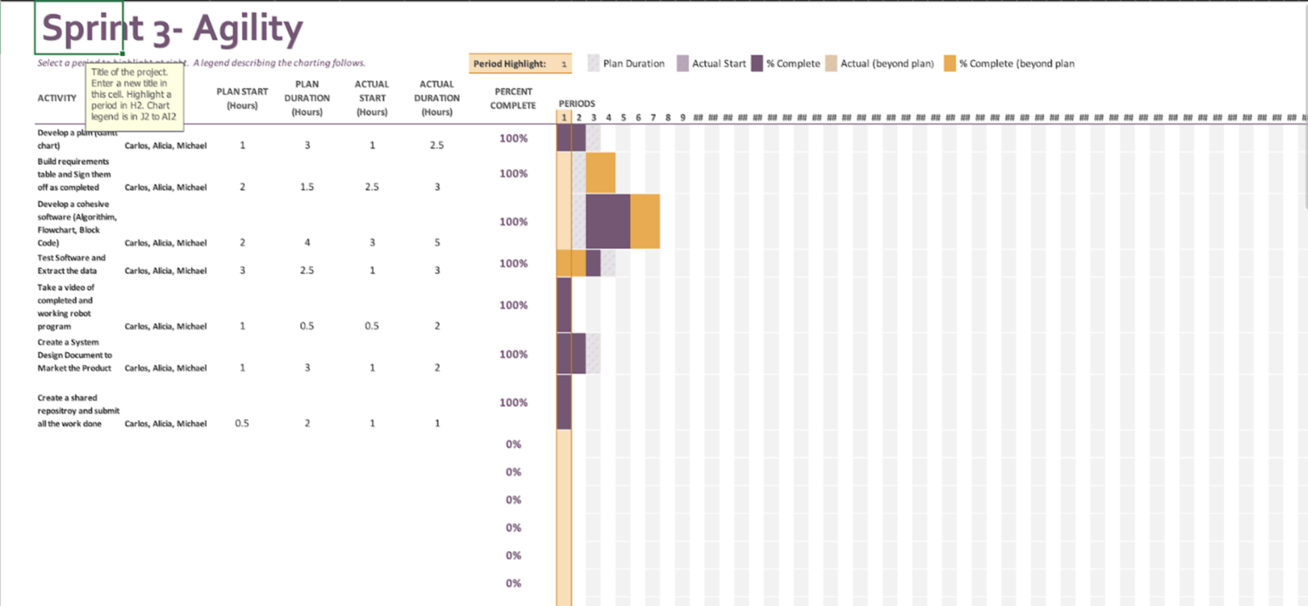

Staffing Plan

Name | Role | Responsibility | Reports To
Carlos Navarro | Planner | Organizing the role of each group member. Carlos made sure that there was clarity between group members in what each other’s roles were and executed his role to the best of his ability. | Michael Mendoza
Michael Mendoza | Engineer | Michael was in charge of the inner workings of the robot. He led the group in software engineering and developed a sophisticated algorithm that made the robot usable. | Alicia Sanchez
Alicia Sanchez | Organizer/ Promoter | Alicia was in charge of putting together the marketing plan for our robot. She was the voice behind our description in the System Design and organized the group members work. Her role was to make our product as desirable and marketable as possible | Carlos Navarro

